Game Design Document

Fill up the following document

1. Write the title of your project.

Hungry Rabbit game

1. What is the goal of the game?

To feed the hungry rabbit with carrots.

1. Write a brief story of your game.

There is a hungry rabbit who needs to eat carrots without getting collided with the stones.

1. Which are the playing characters of this game?

* Playing characters are the ones who respond to the user based on the input from the user.
* Cars, monkeys, dinos, wizards, etc., are the playing characters in the game.

|  |  |  |
| --- | --- | --- |
| Number | Character Name | What can this character do? |
| 1 | rabbit | Eat |
| 2 |  |  |
| 3 |  |  |
| 4 |  |  |
| 5 |  |  |
| 6 |  |  |
| 7 |  |  |
| 8 |  |  |

1. Which are the Non-Playing Characters of this game?

* Non-Playing characters are the ones that don't have an action or behavior when the user interacts with the game.
* Hurdles, stones, bananas, coins, etc., are non-playing characters in the game.

|  |  |  |
| --- | --- | --- |
| Number | Character Name | What can this character do? |
| 1 | carrots | Eliminate the hunger of rabbit. |
| 2 | stones | Hurt the rabbit |
| 3 |  |  |
| 4 |  |  |
| 5 |  |  |
| 6 |  |  |
| 7 |  |  |
| 8 |  |  |

Draw your imagination of this game. What does this game look like?

* Draw the game either on your computer or on paper.
* Add images of the game scenes to show each of the playing and non-playing characters at least once.

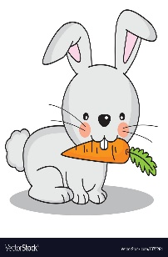

How do you plan to make your game engaging?

The player will go through challenges like avoiding to collide with the stone

and feed the rabbit.